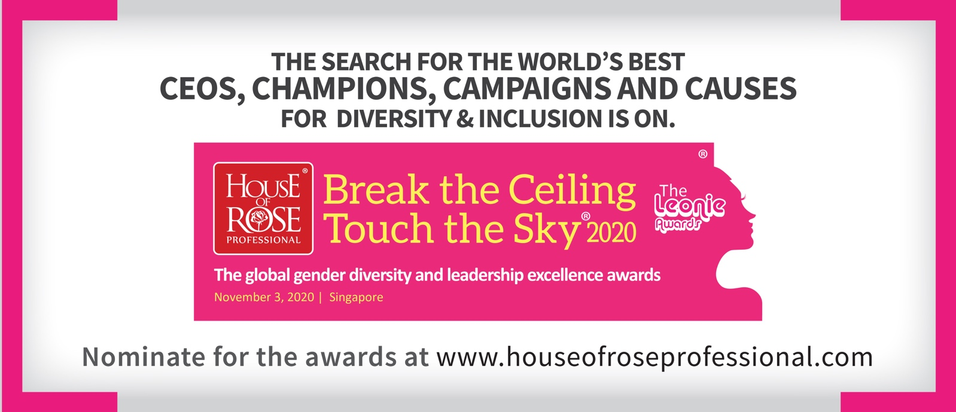

HOUSE OF ROSE PROFESSIONAL’S 2020 BREAK THE CEILING TOUCH THE SKY® LEONIE AWARDS
– For global gender diversity and leadership excellence:

Presented on Nov 3, 2020 evening in Singapore after the 2020 World Edition of Break the ceiling touch the sky®

(Subject to COVID-19 restrictions permitting face to face events or else will be presented virtually)

Company Name:

Leader filling this form/ Company Rep Name:

Office email:

Telephone No:

Category for which Nominated (Please tick from below):

☐Best Companies For Diversity & Inclusion
The most inspirational overall Diversity & Inclusion strategy/ program that encompasses all forms of diversity – gender, nationality, race, disability, style, etc. Could be national / regional / global. Clear track record of the intervention having measurable success.
- Integrates diversity & inclusion as fundamental to its business success
- Advances women/diverse talent across management levels – hiring, growing and promoting women leaders – Has strong female representation on its Board
- Provides excellent workplace and support facilities for leadership , no pay gap between the genders
- Innovates to share and reapply diversity & inclusion practices from within and without
- Supports diversity & inclusion across industry by supporting external forums like Break the ceiling touch the sky in real and tangible ways – time and money

☐Best CEO’s Leading on Diversity & Inclusion
Listing of Best CEOs/General Managers for diversity and the advancement of women in leadership. And overall Diversity & Inclusion. Highlights the top 101 CEOs/General Managers who have best integrated and leveraged gender diversity as a competitive advantage for their organization.
- Role models diversity best practices
- Ensures gender balanced representation on his/her leadership team
- Makes his leaders accountable for gender diversity/D&I being unlocked as core to the company’s business versus nice to have
- Proves the positive impact of diversity on business results
- Supports diversity across industry by supporting external forums like Break the ceiling touch the sky in real and tangible ways – time and money

☐Best Human Resources Leaders
Listing of Best HR gender diversity champions – Highlights the outstanding achievements of the Head of Diversity in an organization that has demonstrated outstanding leadership and commitment to leading and executing the gender diversity agenda through the organization and beyond.
- Is able to make a case for diversity & inclusion and get engagement/financial support from his/her leadership for execution.
- Constantly innovates, shares and reapplies best practices on gender diversity to the benefit of his or her company
- Role models collaboration to step change advancement of women in his/her industry
- Actively supports participation of his/her Company’s teams at external Forums such as Break the ceiling touch the sky® versus just seeking to promote company at such forums
- Has an active strategy in place to make gender diversity core to his Company’s success

☐Best Diversity & Inclusion Leaders
Listing of Best HR gender diversity champions – Highlights the outstanding achievements of the Head of Diversity in an organization that has demonstrated outstanding leadership and commitment to leading and executing the gender diversity agenda through the organization and beyond.
- Is able to make a case for diversity & inclusion and get engagement/financial support from his/her leadership for execution.
- Constantly innovates, shares and reapplies best practices on gender diversity to the benefit of his or her company
- Role models collaboration to step change advancement of women in his/her industry
- Actively supports participation of his/her Company’s teams at external Forums such as Break the ceiling touch the sky® versus just seeking to promote company at such forums
- Has an active strategy in place to make gender diversity core to his Company’s success

☐ Best Marketing Campaigns/Marketers
Gender Diversity Marketing and activation Campaign of the year Award. This award recognizes a marketing effort or campaign that has played a major role in supporting gender diversity or the advancement of women in the workplace both in talk and in “walk” and the Marketing leader behind the effort
- Delivers a specific and tangible business result based on a unique diversity & inclusion insight
- Cuts through the industry clutter and rises above the negativity associated with lack of progress on diversity & inclusion
- Has a direct and traceable impact on the lives of the target of the campaign
- Is potentially reapplicable for other brands/ companies to reapply and further impact diversity
- Is consistent with the “business with purpose” credo

☐ Best Inspirational Women Leaders
The most inspirational woman leader of the year award recognises the significant contributions a female leader has made not just to her business, but also as an inspirational role model for other professional women and in her community.

- Outstanding woman in business that towers above peers for her contribution to her business but also to society and to gender diversity in particular
- Has actively supported gender diversity as one of her key principles on her road to success
- Has a proven track record of empowering other women leaders and is a mentor for men as well
- Is regarded as a game changer in her industry based on her business results but also on the manner in which she delivers those results
- Is a champion “teacher” – her organizations continue to bloom long after she has left them

☐ Best Male Champions for Gender Diversity /Diversity & Inclusion
Listing of Best Male Champions who supports gender diversity and the advancement of women. Celebrates a male leader who has demonstrated outstanding commitment to the advancement of women in leadership and overall progress of gender diversity.
- Makes a strong case for gender diversity based on fact and specific actions versus hyperbole
- Visibly demonstrates advocacy for the advancement of women
- Supports gender diversity on his team and ensures fair opportunities for women leaders
- Suitably supports the delegation of women leaders to industry learning events and summits
- Is available as a trusted member to women in leadership

☐ Best HR Team/ D&I Team
Recognises the best entire D&I teams of a Company versus an individual for inspirational D&I leadership within their own Company and within the broader industry. Recognizes the teams contribution to collaborating for greater impact with multiple companies.
- Has an outstanding track record of advancing Diversity & Inclusion in their Company
- Has demonstrably built a pipeline of women leaders for senior leadership positions
- Continues to role model mentorship and advocacy for women leaders and gender diversity
- Has built a sustainable business model leveraging gender diversity and inclusion
- Shares their knowledge internally within his company and outside (recognised beyond their company as an outstanding team)

THREE STEPS TO COMPLETE NOMINATIONS:
- Nominating leader downloads and fills out nomination form – one per entry and outlines in 1000 words and makes the case with fact, testimonials and data for this particular entry.
- Nominating leader then makes contribution of 150 USD for each award nomination. 75% of this entry fee is donated to charity.
- Nominating leaders email entries by Aug 15, 2020 to breaktheceilingtouchthesky@houseofroseprofessional.com and cc anthony@houseofroseprofessional.com along with receipt number from paypal.

WHAT HAPPENS NEXT:
- Shortlist of Finalists per category will be decided by jury and finalists informed by Sept 30, 2020
- Top 10 rankings will be announced at the Awards Ceremony of Break the ceiling touch the sky® Leonie Awards on Nov 3, 2020 alongside the 2020 World Edition of Break the ceiling touch the sky®
- Please note that Finalists for the awards will be expected to have a minimum of 5 delegates signed up for the 2020 World Edition of Break the ceiling touch the sky® 2020 . Registration for the summit enables free access to the Leonie awards session.

EXPOSURE FOR THE AWARD FINALISTS AND WINNERS:
- Finalists in each category are recognized in summit brochure of the 2020 World Edition of Break the ceiling touch the sky®
- Winners celebrated in special Leonie awards EDMs circulated to 5000 influencers across the world from House of Rose Professional’s proprietary database of C suite leaders and other Company promotional vehicles
- Special promotion via network partner publication/media
- News release on winners within 24 hours of awards ceremony
- Additional profiling as possible in relevant media

